**Assignment -1**

Html form

|  |  |
| --- | --- |
| Assignment Date | 19 September 2022 |
| Student Name | Mr C Sathish Kumar |
| Student Roll Number | 952819106008 |
| Maximum Marks | 2 Marks |

**Question-1:**

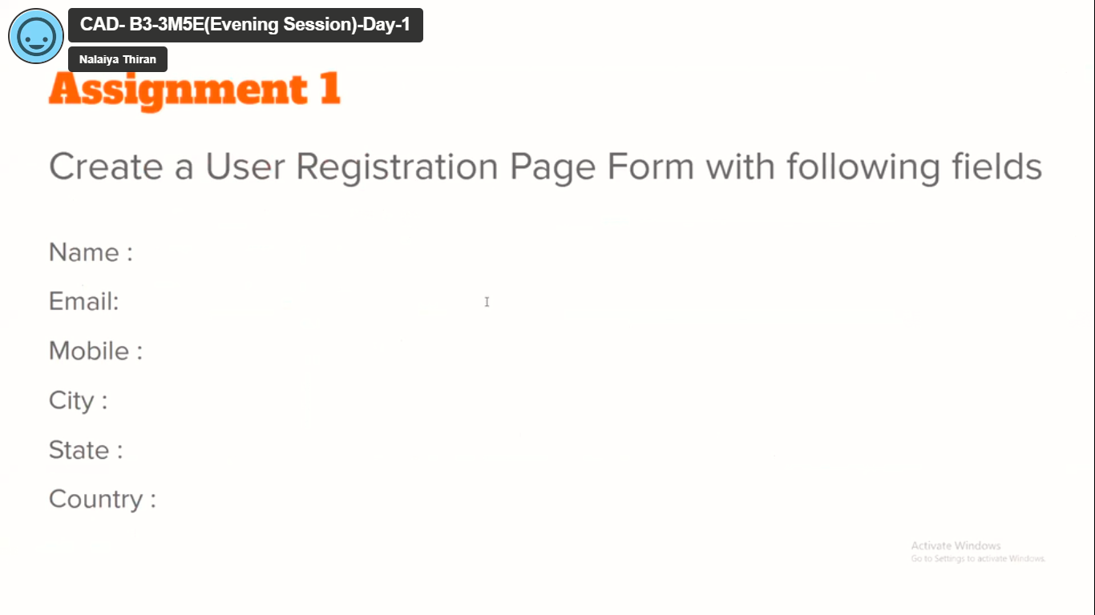

**Solution:**

<!DOCTYPE html>

<html>

    <head>

        <title> assignment_1</title>

    </head>

    <body>

        <form action="/sign up" method="POST">

            <label for= "fname">name</label><br>

             <input type="text" id="fname" name="fname" value="simiyon siluvaimani v"><br>

             <label for="email">email id</label><br>

             <input type-="email" id="email" name="email" value="ssimiyon639@gmail.com" size="28"><br>

             <label for= "mobile"> mobile number</label><br>

             <input type="number" id="number" name="number" value="9049910761"size="10"><br>

             <label for= "city">city</label><br>

             <input type="text" id="city" name="city" value="kalakadu"><br>

             <label for= "state">state</label><br>

             <input type="text" id="state" name="state" value="tamil nadu"><br>

             <label for= "fname">country</label><br>

             <input type="text" id="country" name="country" value="india"><br>

             <br>

             <input type="submit" value="submit" style="color:green;">

        </form>

    </body>

</html>

**Output:**

